Be Cool-Car Pool
A project for 159356



14 October 2008
By: Arlo, Ben, James, Jordan, Parul & Sam

Table of Contents

1. Introduction 2
2. Project Methodology 2
3. Project Plan
3.1 Project Scope 3
3.2 Team Decomposition 6
3.3 Gantt Chart 7
3.4 Measuring Progress 9
4. Design Documentation
4.1 Domain Model 10
4.2 Use Case Diagram 11
4.3 Use Cases 12
5. Risk Mitigation Monitoring and Management 21
6. Software Quality Assurance
6.1 Unit testing 27
6.2 Usability Testing
6.2.1 Methodology 28
6.2.2 Results 28
6.3 Compatibility Testing 30
6.4 Integration Testing 31
6.5 Process Monitoring 32
6.6 JDepend 33
7. Conclusion 34

1. Introduction

Car Pool is an online system being developed to encourage and manage car pooling in Palmerston North. Users register for the service and can use existing Open ID compliant user accounts for this purpose. Users will be able to offer rides and accept offers. When an offer is made or accepted the ride is added as an event to the user’s Google Calendar. This calendar can then send the user automated emails reminding them of their ride. Each user has a social score which is helpful for drivers and riders to identify who contributes to the car pooling community and find out if someone is good or bad rider or driver.

2. Project Methodology

For our project we decided to combine the principles of the Agile methodology with the process framework of Rational Unified Process (RUP). The RUP process framework was applied to the first and second iteration we produced and will also be applied for the final iteration. A single iteration is expected to result in a working part of the system being built and multiple iterations (in our case three) are expected to result in the fully integrated complete product.

RUP has the following four phases: Inception, Elaboration, Construction and Transition. Inception and Elaboration involve identifying the various actors with which the system will interact and defining the nature of this interaction. To this end we develop design documentation that helps us define the scope of our project. We do this using Unified Modeling Language (UML) for the most part. Risk assessment is done in the form of Risk Mitigation Monitoring and Management (RMMM). A project plan, defined using Gantt chart, along with the scope for iterations, is also expected from the aforementioned phases. These are ‘live’ documents that are expected to evolve and change over the course of various iterations. The Construction phase involves the actual building of the components along with integration and testing. And finally the Transition stage involves ironing out any tiny problems and putting in features that were postponed. As stated before all iterations will have all four of these phases.

RUP recommends modeling visually which is why UML is used to create the design documentation. The modeling is done in a Just in Time (JIT) basis as prescribed by Agile methodologies. This means that the scope of the model is restricted roughly to what is required to be implemented in the near future (e.g. 3-4 weeks). Agile methodologies prescribe avoiding Big Design Upfront (BDUF) because requirements are expected to change over the course of the project anyway! Therefore though we have developed an overall design for a system, this design is subject to change depending on our project’s evolution. The same principle is applied to our project plan. Our Gantt chart focuses on planning in detail for the near future for the most part and we continually reassess and extend the chart depending on how the project proceeds. Agile methodologies also prescribe addressing priority features at a time which is why at the beginning of the project a scope will be identified for each of the three iterations which will define what features will be developed for that iteration.

3. Project Plan

3.1 Project Scope

Below appear the scopes for our first, second and final prototype. These have changed and will continue to change as the project continues depending on how well or bad our progress for a particular iteration is proceeding and the changing priorities of the features expected from our project.

Scope for Prototype One

The aim of the first prototype was to achieve successful integration of calendar, database and user login with the website.
- Users can register for system using Open ID accounts
- Users can log into system successfully
- Users can add a ‘one-off’ ride offer by specifying location from and to, the date and time, and the seats available in text fields.
- The ‘one-off’ offer event gets added to user’s Google Calendar if they have one.
- Users can see a list of all the rides available in the database
- Users can accept a ride.
- The database of users and locations can communicate with the web interface.

Scope for Prototype Two

The aim of the second prototype was to evolve the website into a more user-friendly version with most of the functionality that one would expect from a car pooling site.
- Users can register for the site using a username and password if they do not have an Open ID. Users can log in with this username.
- Users can edit their details.
- When creating a ride offer the users have to select streets from a combo box and specify the house number they are departing from. Users can add any other comments as well.
- When users are accepting a ride offer they are taken to the appropriate ‘accept a ride’ page and they are able to specify the location they would like to be picked up at along with any other comments.
- The Ride page should show the current users in the ride and where they are being picked up from
- Google Maps is integrated with the ride page to illustrate the locations the ride will pass during its travel.
- Users can search for rides.
- Users can see a list of rides they have offered and accepted from their account page.
- Driver and Rider can talk via Comments on the Ride page
- Ensure major functionality works on the Massey server where the site is hosted

Scope for Prototype Three

The aim of the final prototype is to add all postponed features necessary for the success of the project and achieve maximum security and usability that we can for the site
- Safeguarded registration
- Users can withdraw rides offered and edit these ride details. Users can withdraw from rides.
- The user who offered the ride is given the choice of being able to confirm or deny the acceptance of a user after which the ride gets added to the user who accepted the ride’s account
- After acceptance by driver the rider can add the ride to their Google Calendar
- A social scoring system will be implemented
- The website will follow good HCI principles – a better layout
- Input Validation
- Site works without cookies enabled
- Ensure all functionality works on the Massey server where the site is hosted

Changes made to the Scope since last iteration (Iteration One)

As explained earlier all design and planning documents are subject to change during the course of the project in keeping with the project methodology we prescribe to. This proved really useful as after completing our first iteration we came to the realization that certain features we were planning were either going to be redundant or not useful for our project. The changes we have made to our scope since iteration one will be outlined below with an explanation of why the changes were made:

During Iteration One, in our design documentation and scope we had stated that a user will be able to add ride offers as well as ride requests with our system. Since then we have revised the scope of our project and will now only be offering users the ability to add offers. The group felt that the system we are building relies on certain users being helpful and offering others rides. It does not seem plausible that not only do these users have to offer rides every time they make a trip but they also have to search through the requests page to see if they are going in the same direction as other users and thus try and fulfill their requests. It is up to the users who want to go somewhere to look through the system and see if ride offers they want are available.

Furthermore, the idea of users ticking a checkbox in the Offer A Ride page to specify if there will be a return trip or not has been discarded. Should there be another trip from departure location back to start location this should be treated as a separate offer that the user adds the system. This is because some users may want to be in the ride going one way but not back. If the seats available were to reduce to 0 despite the fact that one person is not going to be taking the ride back then another user who did need the ride back but did not need the ride to the place is disadvantaged. Additionally other users may want to know of the trip back which they wouldn't find out about as that return ride information would only appear as a mention in the original ride page.

We have also decided that instead of having the driver specify which locations they will be traveling via we shall now have the rider specify where the driver can pick them up. The driver has the right to decline the acceptance of their offer.

Proposals made for our project such as users being able to specify more than one date for a ride, ride events being able to be added to any calendar the user wants not just the Google calendar and the users being able to have an RSS feed for rides from and to certain locations that they are interested in are under re-evaluation currently. These are features that will enhance our system however we may not have time to implement them anymore.

Following the recommendation of our clients (the lecturers) for the second prototype we reduced the scope of our system to streets within Palmerston North only instead of the system being used to organize rides from one city to another. However, we have in the last week also received advice that street names should not be ‘hard coded’ within our system and that we should expand the scope of our system to more than Palmerston North. We have discussed various options within our group and are currently considering how to proceed. We believe that it is necessary to have the users choose from a list of streets for the most part in order to avoid variations on names and typos resulting in invalid street names which will affect the consistency and effectiveness of our web site. Moreover the street names are not ‘hard coded’ per se as the streets are entered into the database through a text file of street names so our project is relatively scalable. We may ask our users how they feel about choosing street names as opposed to writing them out during usability testing. Additionally for the moment we have the facility of asking us to email users if they cannot find a desired street name so that once we confirm the validity of the street name we can add it to the database through the text file of names and inform the user of this change. In order to expand the scope of the site Land Information New Zealand’s database of current street names can be used by future developers to get the information required.

Changes made to the Scope since last iteration (Iteration Two)

Not many changes were made to the third iteration’s scope. Only offering of regular rides was dropped as a feature to be implemented due to lack of resources and time. This was in keeping with the order of the priority of the features that we created in our Risk Monitoring Mitigation and Management Plan. Input validation was added as a feature that was considered important to implement along with the site working without cookies enabled. These were added because we felt we would be able to complete this features and while the former was something we considered very important the latter was decided to be done due to something a lecturer mentioned during our second prototype demonstration.

3.2 Team Decomposition

Our team is composed of six students currently taking the 159356 paper. At the beginning of the project an introduction post was created, in the Google Group we created for the purposes of communicating about this project, where members listed the various skills they had that may be of relevance to the project. This post was taken into consideration when members were assigned tasks. However, it was also agreed that as students we were willing to take tasks in which we may not have prior skills. Therefore, the post was in fact a helpful way of establishing who a member may approach for help if they are not familiar with the language or application they need to use but some other member has listed that they are familiar with the subject in the post. The table below lists the various skills the members listed and the tasks they have done over the course of the projects.

Member Name | Skills | Tasks
Arlo | java, servlets, jsp, php, css, javascript, html, setting up a basic server | Making the web interface, Developing and maintaining the website code
Ben | java, javascript, ant, junit, sql | Google Calendar, Ensure rider and driver can communicate through comments
James | java, javascript, ant, sql, junit, html | Logging In & Registration issues, User Management, Automating integration, Test cases in JUnit
Jordan | java, mysql, ant, php, html, css | Create and improve database design and implementation , Interface with mysql database to allow communication of data for  storage and retrieval, Test cases in JUnit
Parul | java, uml, junit, ant, html, sql, hci principles | Manage team, Create design documentation, Maintain report, Oversee site and database code and make minor changes, Usability testing
Sam | java, html, uml, ant, junit | Create design documentation, Google Maps

3.3 Gantt chart

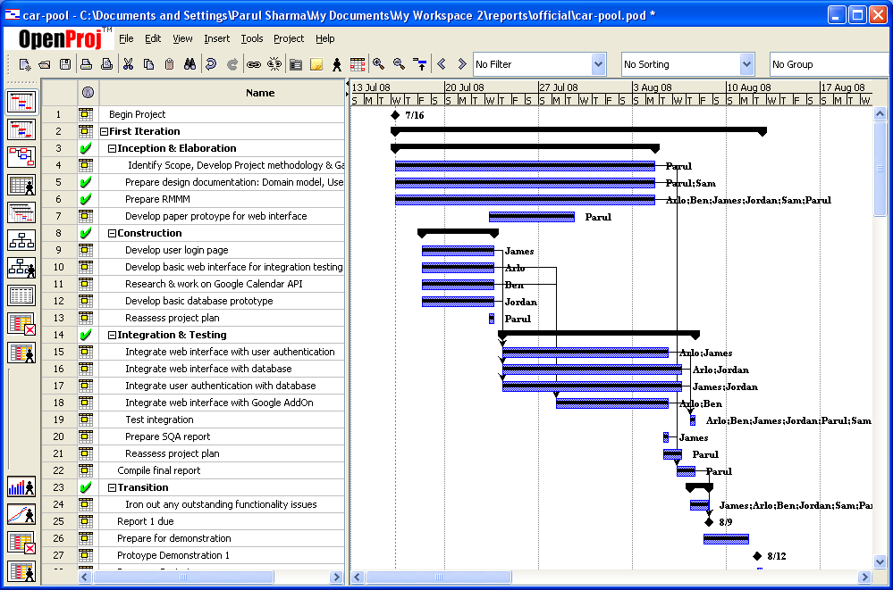
The Project Gantt chart is continually updated as the project proceeds. It is a visual way of gaining an overview of how tasks should proceed throughout our scope. The first iteration, displayed in Figure 1, was focused towards gaining an overview of the system that will be developed, creating the most basic features required and ensuring the various components that will make up the system are integrated well together.
Figure 1: Gantt chart – First Iteration

The second iteration, displayed in Figure 2, focused on expanding the features that will be available through the system. Before all that a usability test of the first iteration prototype was done to get an overview of how well designed the system is for the user and the issues raised from it were added to our plan. In addition the first prototype design documentation and RMMM were revaluated in terms of redefining our scope. After some discussion it was decided that the scope of our project and design documentation should be modified as certain features were no longer needed. All the documentation was updated to reflect this change.

The final iteration, displayed in Figure 3, as has been stated in the Scope for Prototype Three, is going to focus on adding in all the features that were postponed but are equally necessary for the project’s success. Additionally remaining usability, security and optimization issues will be attempted to be addressed.
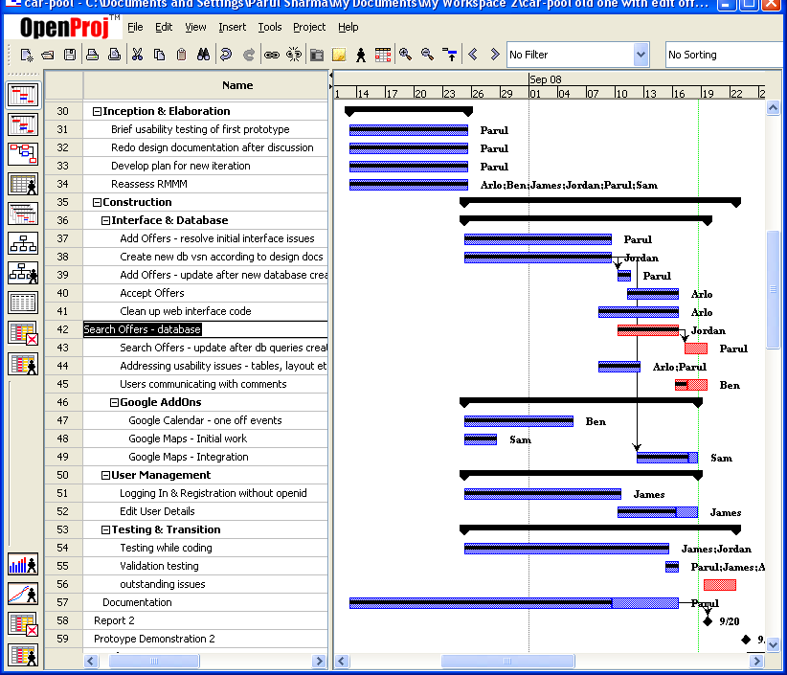
Figure 2 : Gantt chart - Second iteration

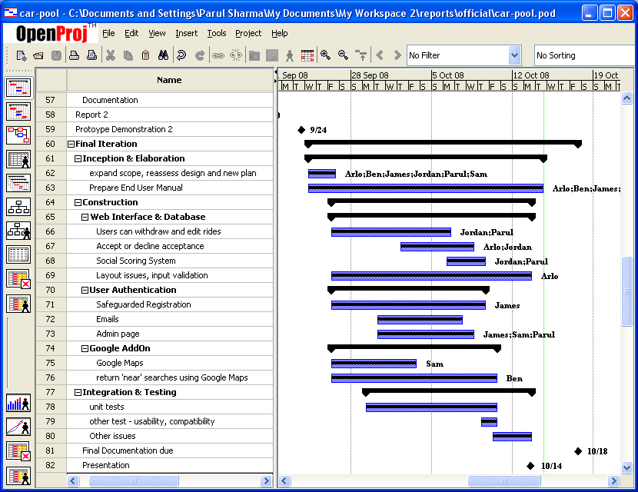

Figure 3: Gantt chart – Final iteration

3.4 Measuring Progress

During the evaluation of our first iteration, as part of our Software Quality Assurance acticity of Process Monitoring, it was suggested that we begin to use Google Code’s Issue Tracking system to measure progress. This system has proven to be a very effective way of managing assigned tasks. All tasks that need to be completed are added as issues and the person who chooses to accept the task becomes the owner of the issue. The owner adds comments to the issue explainaing how they are progressing with the task assigned so everyone in the team has an idea of where the current system’s functionality stands. If members find any defects with the system they are encouraged to add these as issues as well and later this issue is assigned to the person in charge of the module this issue relates to. Figure 4 below displays some of the issues currently in our system. The issues added to the system are not confined to any current iteration or scope – they are reviewed and prioritised and issues that may not be addressed in current iteration are assigned Low Priority.

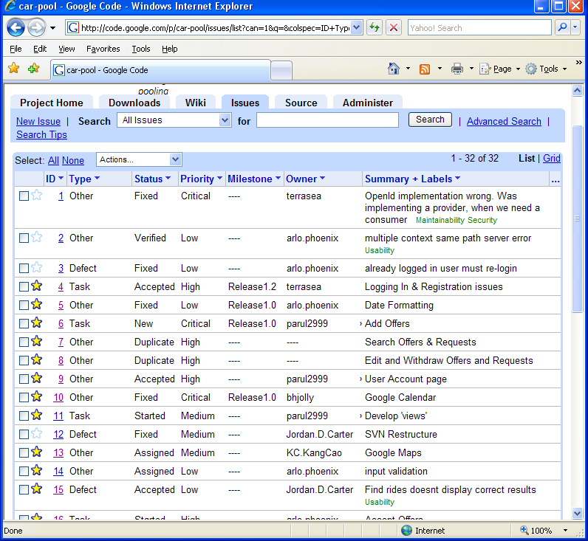
Figure 4: Issue Tracking System

4. Design Documentation

4.1 Domain Model

The domain model is modeled as a class diagram using Unified Modeling Language. It relates the objects that will be in our system’s domain to each other, and helps us identify attributes and methods of these objects.

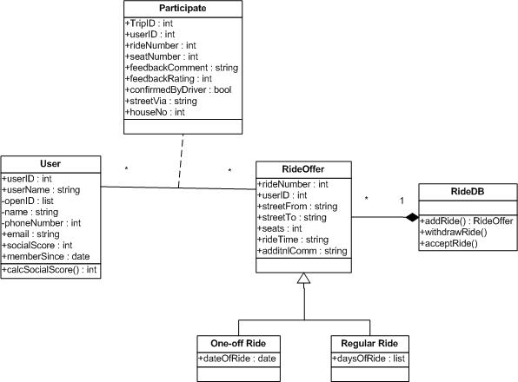

Figure 5: Class Diagram

Note that getters and setters have not been defined as operations for the diagram above. This is because they simply clutter up the diagram and in our opinion they are no more than visual noise.

4.2 Use Case Diagram

The use case diagram helps illustrate the functionality of a system visually in terms of the actors involved, what their goals are and it also helps us identify any dependencies between the use cases.

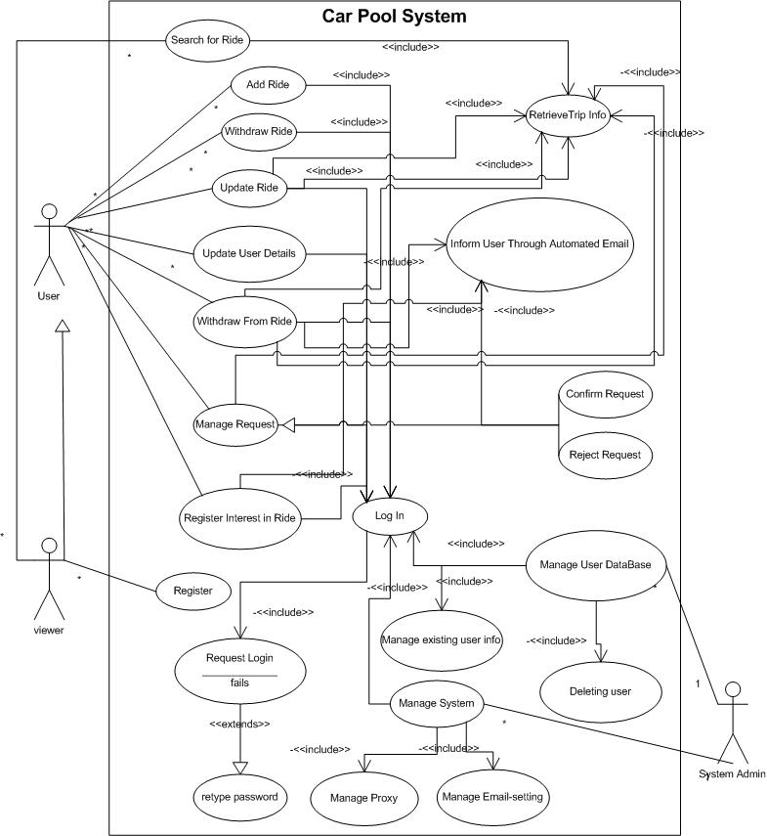

Figure 6: Use Case Diagram

4.3 Use Cases

The use cases describe the interaction between external actors and the system. They are the main frame of reference when constructing the system to ensure that the system does what it is expected to do. Just like the Use Case Diagram they are quite thorough and not just restricted to the current scope because it is good to have a broad vision of the system being built. These use cases are changed depending on how the customer’s requirements or our vision changes.

Use Case Name: | Registering on Car Pool site using OpenID
Actor: | User
Description: | The user should easily be able register on the site so they can start using it. They should be able to use their OpenID to do so.  The system should be able to verify the validity of their OpenID account and save the other details the user has entered.
Pre-condition: | User wishes to be able to use the car pooling website.  The user has an OpenID account.
Typical Course of Events: | Actor:  Step 1. The user enters their OpenID username in the input box on the homepage as directed.  Step 5. The user can choose a username and click “check username availability” And the user can add details such as their email address and phone number. They then enter text used to validate the registration of a user. And finally click on “finish registration” | System:  Step 2. The system redirects the user to the OpenID site so they may log in to their account  Step 3. The OpenID site verifies the username and password.  Step 4. The system redirects user to site again and if the OpenID mentioned is not in system the user is taken to a Registration Form.  Step 6. The system now has a database instance created with user OpenID account, and username stored and system also issues a user id to uniquely identify the instance in the database. The rest of the details are added to the system database too. The system then displays the homepage with the user account box showing the user’s username and a Logout option beneath it.
Alternative Course A: | Step 4. The user tries again. | Step 3. The OpenID site tries to verify the user’s OpenID account. The username and password fail to match. The system displays a page to the user stating that their OpenID account was not validated. And asks them to try again.  Step 5. If this time it is successful then steps continue as per Typical Course of Events Step 4 otherwise it keeps repeating Alternative Course A till successful or users stops trying.
Alternative Course B: | Step 5. If on clicking Check Availability the User finds their username taken They choose another username and click “Check Availability” again. | Step 6. The system checks the database to see if any other user has the same username.  Step 7. If the name is being used by someone else the system tells the user they cannot have the username and must choose another one.  If username is available then events can continue as per Typical Course of Events Step 5 otherwise Alternative Course B repeats till success achieved or user stops trying.
Post-condition | The system now has the user’s details stored in the database  The user has successfully created an account with the system  The user is taken to the homepage where they can choose what to do next.
Assumption: | Usually the user doesn’t enter the wrong password for their Open ID account.  Usually the username chosen is available.

Use Case Name: | Registering on Car Pool site using username and password
Actor: | User
Description: | The user should easily be able register on the site so they can start using it. They should be able to sign up using a username and password  The system should be able to save the other details the user has entered to the account they just created.
Pre-condition: | User wishes to be able to use the car pooling website.  The user wants to sign up to our site using a username and password
Typical Course of Events: | Actor:  Step 1. The user clicks the Register link  Step 3. The user can choose a username and click “check username availability” And the user can add details such as their password, email address and phone number. They then enter text from the image used to safeguard the registration process. And finally click on “finish registration” | System:  Step 2. The system directs the user to the registration page.  Step 6. The system now has a database instance created with user username & password stored and system also issues a user id which is also stored in the database. The rest of the details are added to the system database too. The system then displays the homepage with the user account box showing their username and a Logout option beneath it.
Alternative Course A: | Step 3. If on clicking Check Availability the User finds their username taken They choose another username and click “Check Availability” again | Step 4. The system checks the database to see if any other user has the same username. If the name is being used by someone else the system tells they cannot have the username and must choose another on.  Step 5. If username is available then can continue as per Typical Course of Events Step 3 else repeat Alt Course A till successful.
Post-condition | The system now has the user’s details stored in the database  The user has successfully created an account with the system  The user is taken to the homepage where they can choose to do what they want.
Assumption: | Usually the username chosen is available.

Use Case Name: | Edit User Details
Actor: | User
Description: | The user should easily be able to change any details they would like to.
Pre-condition: | The user has account on the system.  The user is logged into that account.  The user wishes to change some details of his/her account (e.g. email)
Typical Course of Events: | Actor:  Step 1. The user clicks on the link that takes them to their account details page.  Step 3. The user changes the detail they want to. They are only able to change their: email address, phone. The user can also add additional Open IDs. The user clicks the Save Changes button. | System:  Step 2. The system takes the user to their account page.  Step 4. The system saves the changed details appropriately in the database and on the other required pages.  Step 5. The system shows user their account page with the changed details.
Post-condition | The system now has the user’s changed details stored in the database  The user has successfully changed the details they wanted to  The user is shown they were successful.

Use Case Name: | Add an Offer
Actor: | User
Description: | The user should easily be able to add an offer for a Ride and the system should store the details of this offer as the user has entered them.
Reference to requirements | (link to written requirements)
Pre-condition: | The user has an account with the site.  The user is logged into that account.  The user wants to offer a ride from a certain location to another location on a certain date/certain days.
Typical Course of Events: | Actor:  Step 1. The user clicks on the Add Offer button  Step 3. The user enters the following details:  a. Ride From Street  Ride To Street  (the only regions available are Palmerston North due to the scope of this project)  b. The user then encounters the option between One-off and Regular and chooses one. There is no default option so the user is forced to make a decision.  c. The user then can add information regarding departure time and approximate length of trip in minutes  d. The next field the user fills is of the number of seats available.  e. The user chooses if they want to receive emails if someone comments on the offer or accepts it.  f. The user finally clicks the Add Offer button. | System:  Step 2. The system takes the user to the Offer Form  Step 4. The system generates a Ride Id and then saves the Offer details associated with it.  Step 6. The system adds the ride to the user’s Google calendar. The system takes the user to a page announcing the Ride has been successfully offered.
Alternative Course A: | Step 3b. The user chooses Regular ride option  Step 5. User chooses the appropriate days and the rest continues from step 3c in Typical Course of Events. | Step 4. System displays the Days of Ride field where user can enter the days they will be traveling.
Alternative Course B: | Step 3b. The user chooses One off ride option  Step 5. User enters the appropriate date and the rest continues from step 3c in Typical Course of Events. | Step 4. System displays the Date of Ride field where user can enter the date they will be traveling.
Post-condition | The system now has the offer details stored in the database  The user has successfully created an offer. This offer can be accessed from the User’s Account where the user may edit details and withdraw offer as long as no one has signed up to it.  The user is taken to a page informing them the request has been successfully added.
Assumption:

Use Case Name: | Accept an Offer
Actor: | User
Description: | The user should easily be able to accept an offer.
Reference to requirements | (link to written requirements)
Pre-condition: | The user has an account with the site.  The user is logged into that account.  The user has searched for rides and found a ride offer they would like to accept.  The user has, if they wanted to, discussed in the comments of that ride page whatever they need to with the person offering the ride.  The user is on that Ride’s page.
Typical Course of Events: | Actor:  Step 1. The user clicks on the link that leads to the relevant Ride Page.  Step 3: The user specifies what street they would like to be picked up from.  Step 4. The user clicks the accept offer button. | System:  Step 2. The system takes the user to the Ride page.  Step 5. The system sends the person who offered the Ride a message through their account page asking if they agree to pick the user up at the location they have specified. That user clicks confirm.  Step 6. The system sends the user who accepted the ride a message through their account page informing them of the confirmation and the user can now click Add Ride as Event to Google Calendar.
Alternative Course A: | Step 5. The user who offered ride clicks on the Decline Acceptance button. | Step 5. The system informs the person who accepted the ride that the driver will not be able to pick them up from their preferred location and their acceptance was declined.
Post-condition | The user has Accepted the Offer. If they accepted and the driver has accepted their Acceptance then this offer can be accessed from the User’s Account where the user may be able to withdraw from the ride. The number of seats available is reduced and the ride is added as an event to the user’s calendar.
Assumption:

Use Case Name: | Edit Offer
Actor: | User
Description: | The user should easily be able to change any details they would like to on their offer
Reference to requirements | (link to written requirements)
Pre-condition: | The user has account on the system.  The user is logged into that account.  The user has made an offer for a ride.  That offer has not been accepted by anyone yet.  The user wishes to change some details of that ride.  The user is on their Account page which lists their requests and offers.
Typical Course of Events: | Actor:  Step 1. The user clicks on the Edit button beside the appropriate ride offer.  Step 3. The user changes the details they want to. The user clicks the Save Changes button. | System:  Step 2. The system takes the user to the Edit Offer page.  Step 4. The system saves the changed details appropriately in the database, Google calendar and on the other required pages. The system takes user to a “your offer details have been successfully changed” page.
Alternative Course A: | Step 3. The user clicks Don’t Save Changes. | Step 2. The system takes the user to a page that informs them their changes were not saved.
Post-condition | The system now has the user’s changed details stored in the database  The user has successfully changed the details they wanted to  The user is taken to a page informing them of this success.
Assumption: | The user will only be able to Edit as long as no one else has accepted the ride

Use Case Name: | Withdraw Offer
Actor: | User
Description: | The user should easily be able withdraw their offer
Reference to requirements | (link to written requirements)
Pre-condition: | The user has account on the system.  The user is logged into that account.  The user has made an offer for a ride  This offer has not been accepted by anyone else  The user wishes withdraw the offer.  The user is on their Account page which lists their requests and offers.
Typical Course of Events: | Actor:  Step 1. The user clicks on Withdraw button beside the appropriate ride.  Step 3. The user clicks Yes. | System:  Step 2. The system takes the user to “I really want to delete this offer” page.  Step 4. The system deletes offer details from the database and other pages such as Google Calendar and displays “offer has been deleted” page to the user.
Alternative Course A: | Step 3. The user clicks No. | Step 2. The system takes the user to “offer has not been deleted” page.
Post-condition | The system now has deleted the offer from database and user’s accounts.  The user is taken to a page informing them of this.
Assumption: | The user will often go ahead with the deletion.  The user will only be able to as long as no one else has accepted the offer

5. Risk Mitigation Monitoring and Management Plan (RMMM)

The following RMMM was developed in consultation with our team. Mitigation and Monitoring measures have been taken, where possible, to avoid and keep track of the risks listed and if we do encounter a problem eventually we will be able to employ our Management strategy to deal with it.

Feature Priority Order

The list is a document for the risk “Running out of time to accomplish tasks specified in scope of current iteration” mentioned in the RMMM and has been established based on what requirements our customers (the lecturers) have explicitly stated in the written outline provided to us a well as discussion between the members of what is required for the success of our project. The Feature Priority Order is defined to give an idea of what features to cut back on if the project’s progress is lagging behind and the scope of the system needs to be reduced.

- Registration & Logging In of users: Open ID
- Add One off Offers
- Google calendar: one off event
- See all available offers
- Accept offers: can specify via which location to be picked
- Registration of users: username and password
- Search for rides
- Google maps integrated
- Accept acceptance from account page
- Edit ride details from account page
- A social scoring system
- Accept offers: can specify number of seats you want
- Safeguarding registration
- Send automated email notifications
- Add Regular Offers
- Google calendar: regular event
- Add Requests
- Add Counter Offers to Requests
- RSS feed
- Abstraction of Calendars

Risk | Category | Probability | Impact | Mitigation | Monitoring | Management
Running out of time to accomplish tasks specified in scope of current iteration | Project | 90% | 1- Catastrophic | As we are all university students with other assignments to complete so it is likely that despite all our planning we may not have time to accomplish all that we set out to do. This problem may be unavoidable but project plans created with mutual agreement should help avoid some issues. | Weekly meetings and using the Issue Tracking system on Google Code will help us monitor our progress and adjust each week's plan accordingly. | A document should be created detailing the priorities various features have so that in the event that there is not enough time to accomplish all tasks we are aware what features should be left out of current iteration or perhaps the project itself
Open ID can't work due to security configurations preventing our application from connectiong to outside urls | Technical | 90% | 2-Critical | This cannot be avoided - it is entirely dependent on the security settings of the site deploying the application | With each release check to see if Open ID works or not and if this is due to security settings. | Find out what security setting are needed to to take into consideration, and see if a proxy server can be used or not. If so get the address and port of the proxy server and have the aplication use this.
Change in requirements means design documentation is no longer valid | Project | 80% | 2 - Critical | This cannot be avoided. The process methodology we use is not focussed on Big Design Upfront but instead follows a model-only-as-much-as-you-need approach | Weekly, and after each iteration, discuss the requirements and what is about to be implemented and discuss how this affects design document. | Each time a change is made in the requirements or plan of what is to be implemented all design documents should be updated to reflect the changes. Also document all changes made in weekly team report to manage and keep track of them. Ensure all changes are communicated to appropriate stakeholders.
Security Issues | Technical | 70% | 1 - Catastrophic | We need to decide early on what can access what and who can change what. Make views, ensure users are not interacting with database directly. Use privileged accounts with restrictions. | Continual stress testing | If a security vulnerability is identified inform affected stakeholders and find a solution to problem as soon as possible.
Server issues | Technical | 70% | 1-Catastrophic | Since we are unable to get direct access to the server of our choice this risk is inevitable and unavoidable. Open communication with IT person who has given us access to the server to help narrow down the reson for issues is recommended. | Two weeks prior to an iteration's deadline the unfinished war file should be attempted to be deployed on server and if issues occur then there will be enough time to solve them. | If a server issue does occur during the prototype demonstrations then the demonstartion will have to be done on a member's laptop. This however is not recommended and trying out project on server with enough time to solve issues is the approach that will be given more weight.
Damaging communication - automated worms may sign up and steal people's email addresses to send them fake emails | Technical | 70% | 1-Catastrophic | Safeguard the registration process through asking confirmation of registration through validation link sent in email or by asking user to type in numbers in static image during registration | Run a firewall and regular virus checks with the latest virus scanner independent of the rest of the network. Keep up to date with the latest virus and other malicious entities hitting the internet and take steps to handle an attack from them | If a worm is discovered aim to find vulnerability and resolve it, aim to stop the worm or virus spreading further. Advice relevant stakeholders
Usability Issues with final product | Business | 70% | 2 - Critical | Incorporate in project plan time to ensure site is assessed and redone to follow good HCI principles | Use prototypes and do beta tests. Get user feedback and attempt to solve major issues with User interface. | If after release the interface is seen as having issues see if steps can be taken to solve issues.
Lack of experience with tools/ languages/ concepts | Staff | 70% | 2 - Critical | At onset of project find out which team member has experience and and are comfortable with what tools. Choose tools that most members are familiar with. | Continually discuss how the members are finding their experience with new tool/ language/ concept. | If a member is struggling with a certain tool/ language/ concept then hunt appropriate tutorials that will help make one comfortable with tool/ language/ concept. Also ask team manager for help if completely clueless on how to implement something for project
Synchronisation of concurrent access | Technical | 70% | 3 - Marginal | Need to look into a solution as soon as possible and incorporate it into database design. | Continual stress testing | When concurrent issues occur use solution found to deal with issue.
Different software tools used in project are incompatible | Technical | 60% | 1 - Catastrophic | Verify compatibility prior to taking decisions regarding using the software/ tool in the project | Ensure throughtout integration that all is proceeding as planned | If something is not working and integrating as expected then immediately hunt for hacks that might help with compatibility and ask manager. If all else fails get on to finding an alternative as soon as possible and begin implementation through that.Reassess project plan in terms of how much this will set back certain tasks.
Failure to integrate the various components successfully | Technical | 60% | 1 - Catastrophic | Ensure all tools being used are compatible. Allow sufficient time for integration of components in project plan. | Keep track of how integration is proceeding as outlined in project plan. Use Bottom Up testing approach and test ever small feature developed in integrated environment not just in isolation | If integration is encountering problems ask help from manager, look up as soon as possible on how to integrate the different components in question, if integration seems impossible work on plan to find an alternate tool that may be used.
Personal information vulnerable | Technical | 60% | 1-Catastrophic | Run a server with limited access to prevent someone else from getting access to our database | Keep remote records of server access logs that are inaccessible from the internet and monitor these regularly. Use something like | If unauthorized access of database is discovered aim to find vulnerability and resolve it. Advice relevant stakeholders
Damaging information planted | Technical | 60% | 1-Catastrophic | To avoid someone gaining access to our server and adding malicious information or code one could set up a false server that is more easily accessible to lure possible malicious attacks away, slow them down or notify team that  something is in danger | Keep remote records of server access logs that are inaccessible from the internet and monitor these regularly | If unauthorized access of database is discovered aim to find vulnerability and resolve it. Advice relevant stakeholders
Command/SQL injection | Technical | 60% | 1-Catastrophic | It may be possible for users to enter malicious code that runs commands on the server and we can prevent this by thoroughly validating all inputs | Continous stress testing with every added functionality is required to monitor that input is being validated. Run something like nessus (www.nessus.org) to scan site for vulnerabilities before exposing it and with each new release do thorough security testing | If a user is found running commands remove user from site, fix security vulnerability
Problems within team | Staff | 60% | 2 - Critical | Establish effective communication channels at the onset of the project to ensure everyone is aware of what is going on with team and project. Lack of awareness and a feeling of not being involved leads to frustuation | Monitor team morale and ensure through weekly meetings that whole team is aware of how the project is proceeding. Take everyones suggestions on board regarding the project. | If a member has an issue with the team or any problem arises do not avoid issue. Try to identify cause of problem and then try to deal with the problem.
Web Browser Incompatibility | Technical | 60% | 2-Critical | Make sure when coding to look up on how to avoid incompatibility with major/popular browsers. | Test in major/popular environments on a regular basis. | Look for solutions on how to slove incompatibility issue.
Google Map does not work on certain browsers though the website does | Technical | 60% | 2-Critical | Look up information on sites with which the maps are compatible and what needs to be done to make the maps work with verious browsers | Test in major/popular browsers on a regular basis. | Look at Google API and discussion groups for information on how to resolve issue
Unforseen dependencies between various tasks | Project | 60% | 3 - Marginal | Identify all components to be built and their dependencies between each other. Develop proje ct plan with aim to maximize concurrency during development | Through weekly meetings ensure that all tasks that can be completed concurrently are being done so if the resources available allow it. | Assign more resources (members) to task that is holding up other tasks and preventing concurrent development.
Loss of data | Technical | 50% | 1 - Catastrophic | Maintain a backup database | Monitor performance of site and any factors that might cause a crash of the system and thereby loss of data. | Use backup database while trying to recover system.
The user can't find a street name they want to reference in the combo box | Technical | 40% | 2-Critical | This cannot be avoided in the current iteration of our website where street names can only be chosen from the combo box. | Street names in the regions within the scope of the system can be monitored using the Land Information New Zealand site's list of streets. | If a street name change occurs or a new street is created we can add or modify the street name to the list of streets file. Additonally users can be asked to send us an email if they cannot find the street they want in the list and after we verify the street exists it can be added to the list of streets file which is used to import streets into database and we can email them back informing them of the change made
A team member is not available to work during a crucial time. | Staff | 40% | 3 - Marginal | Ensure that a person is not scheduled to complete a task at a time when they have another asssignment due. Ensure everyone is commenting on their bits of code so if another member has to take over they can follow the work. | During weekly team meeting ask if team members have other commitments they need to attend to and if this will impact on their ability to complete the task assigned | If a team member has a sudden emergency to deal with reallocate resources to task they were meant to do depending on how critical the completion of the task is. Reassess project plan.
We change the way addresses or dates are handled within the site | Technical | 40% | 3-Marginal | If this occurs the Google Calendar interface will be affected. It may be unavoidable if there is a need to change the way site handles these inputs | Ensure site is handling dates and addresses in the same way everywhere - maintain consistency | If change is needed in the way addresses and dates are handled ensure that all changes are well documented and all stakeholders (in this case member in charge of Google Interface) is informed of change as soon as possible
Google changes their "event publishing" URL format | Technical | 30% | 3-Marginal | This cannot be avoided as it is a risk because we rely on Google so our user may add ride events to their Google Calendar | It is highly unlikely due to the number of people and companies relying on Google but keep an eye on changes or updates to Google Calendar API | If this does occur then find information on new event publishing format and implement that in system

6. Software Quality Assurance (SQA)

It is important to ensure the quality of the software that is being built and SQA activities can help us do this by ensuring we do not have a lack of conformance to the requirements, explicit or implicit. To this end we plan on implementing the following quality control activities:

6.1 Unit testing

This is important to ensure that individual units in our source code are functioning as expected. We have continued to expand our JUnit test cases for all the database and user management functions we create. They help us gain an understanding of why a certain feature is failing as we can narrow the problem down to a particular failed test case.
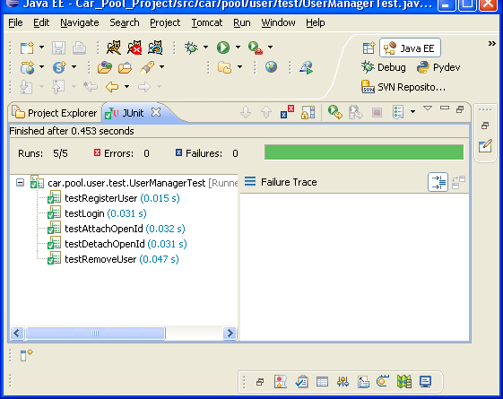
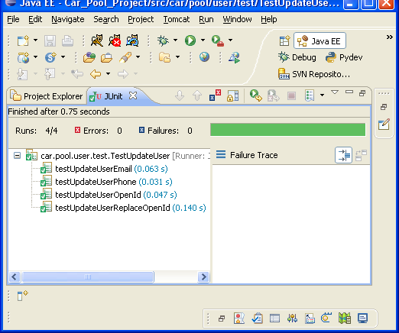
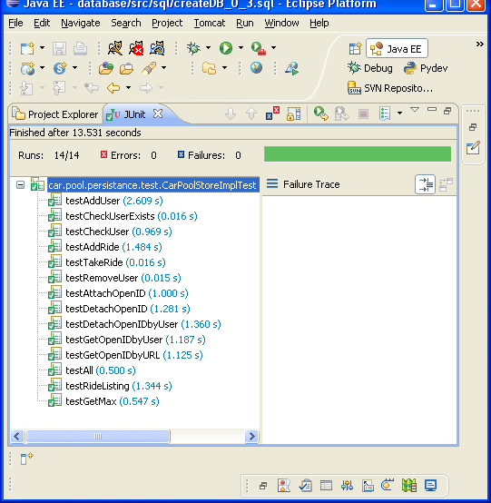

Figure 7: JUnit test cases

6.2 Usability Testing

6.2.1 Methodology

According to leading web usability consultant Jakob Nielsen one only needs to test with five users to discover 85% of the usability issues of a design. Following this suggestion we asked 5 users to evaluate the site. For this particular study quantitative data such as time taken for a user to do a certain task was not collected instead the data collected was qualitative. Each user was shown the site on the interviewer’s laptop. It was explained to them that the site was a car pooling system and that the testing would take place as a Think Aloud Protocol where they were expected to use the site as they desired and say out loud the actions they were taking and what they were currently thinking about the system. The interviewer took notes of what the users said about the site and after the testing was done asked and took notes of the user’s overall impressions and suggestions. Usability testing was conducted after the completion of prototype one so that we could take account of the issues raised by users.

6.2.2 Results from Usability Testing of Prototype One:

Technical Response:

- None of the users knew what Open ID was. This would not be an issue if they could also register on our site with a username and password because then they would be able to choose that option instead. However since this was the first prototype they could only register using Open ID. For the purposes of testing we created Open ID accounts for each of them and gave them the password and asked them to use that for registering and logging into the site. A link to more information on Open ID was added to the homepage for future users who may not know about it but would like to.

- Some users appreciated how after clicking Confirm Registration they were logged into the site directly and redirected to the home page instead of waiting for a validation email to first confirm their registration. However we do eventually need a way of safeguarding registration eventually and the most common way is to send validation emails which we simply had not gotten around to implementing yet.

- When users clicked on Update Details button on Edit Details page and nothing happened they were confused. Though interviewers are not meant to help out users in this case it was explained to them that that functionality had not been implemented yet.

- In the Location To and Location From text boxes in Find a Ride page it was noticed that the location names added were not consistent. Locations like “Palmy”, “Welly”, “PN”, and “NP” were entered in some cases. Based on this result and a mention from our client (lecturers) that the scope of the system should be restricted to something only within Palmerston North instead of the site being used for ‘hitchhiking’ it was decided that standardizing the locations to avoid variations is necessary and therefore combo boxes of street names in Palmerston North were implemented for our system. Though it can be noted that perhaps in a ‘real world’ situation users will usually refrain from using abbreviations, however there is still the possibility of inconsistency through typing errors.

- In the Date field the users disliked entering the date in yyyy/mm/dd format. However we already had plans of changing this for the next iteration to dd/mm/yyyy format in any case and the date formatter just had not been implemented at that stage.

- In Find a Ride page it had to be explained to the users that clicking the name of the From Location would add the ride to the user’s account. It was explained to the user that eventually there will be a link to a page where more details of the ride can be viewed and an Accept Ride button would be present. The current method was simply for demonstration that the functionality did work, if not in a very usable fashion. Some users noted the fact that when they did accept a ride the page reduced the number of seats available for that ride.

Emotional Response:

- Some users felt that an explanation of the aim of the site and how to use it should be given on the home page. A brief explanation has now been added to the homepage.

- Most users expressed reservations about the style of the website. Though in terms of page structures users felt that the site was clear and intuitive, they felt the site did not look inviting enough and did not capture attention. A new layout for the website has been started though it will not be complete in the second iteration.

- On the right menu a user said it would be better to have the username instead of Open Id displayed which they felt was too long. We had planned on making this change in any case and it has been fixed.

- Most users said ‘Find a Ride’ table was not spaced out well enough and looked clustered. This was because the table did not have any borders which have now been added.

6.2.3 Results from Usability Testing of Prototype Three:

Due to lack of resources and the fact that we still had not implemented our changed layout we did not test our site on users for the second prototype. After we had implemented the new layout and input validation we did a brief usability testing on two users

6.3 Compatibility Testing

The following is a list of Operating Systems (OS) and web browsers that our website appears and functions correctly in. This list will be expanded to ensure our application has maximum compatibility with the majority of environments it will be accessed from.

Browsers & OS | Comments
Windows XP  Internet Explorer 7 | Layout and functions OK. But Google Map does not work for Ride Confirmation page.
Windows XP  Firefox 3.0.1 | Layout and functions OK. Google Map works.
Windows XP  Opera 9.52 | Layout looks slightly different. Functionality works fine. Google Map works
Windows Vista  Firefox 3.0.1 | Layout looks slightly less good. Functionality works fine. Google Map works
Windows Vista  Internet Explorer 7 | Layout looks slightly less good. Functionality works fine. But Google Map does not work for Ride Confirmation page
gentoo-2008 linux  firefox 2.0.0.16 | Layout and functions OK. Google Map works.

6.4 Integration Testing

Successful integration of all components is an essential part of our project. For our iterations we followed a Bottom Up approach of designing and thus integration testing. The Google add-ons, database and web interface were developed, and expanded in second iteration, independent of one another and these small systems were then pieced together and the integration tested. When we update our project and test our integrated site we go through the following list to ensure we are keeping track of everything. This list is expanded as more features are added. The current list was updated on 18th September.

Feature | Working on Our Computer | Working on Massey Server
Registration: Open ID | Yes | Yes
Log in: Open ID | Yes | Yes
Registration: Username-pw | Yes | Yes
Can check availability of username | Yes | Yes
Log in: Username-pw | Yes | Yes
Add a Ride: One-off | Yes | Yes
Google Ride Event: One-off | Yes | Yes
See all rides on Find a Ride | Yes | Yes
Can search rides | Yes | Yes
Can see details of a Ride when link clicked for the ride. | Yes | Yes
Can accept a ride from that link | Yes | Yes
Can see user details on user’s personal account page and update those details | Yes | Yes
Can see details of user when profile page link clicked | Yes | Yes
Can see list of user’s offers on user account page | Yes | Yes
Can see list of : rides offered, rides awaiting approval for, rides accepted for, riders awaiting approval for ride | Yes | Yes
Can Provide Feedback | Yes | Yes
Can write comments on a ride page | Yes | Yes
Can confirm and reject users. | Yes | Yes
Can update ride details | Yes | Yes
Can send helpful emails to users | Yes | Yes
Can Log Out | Yes | Yes

6.5 Process Monitoring

As part of trying to implement a means of Software Quality Assurance we monitored the software engineering process and methodologies we were employing. The aim was to ensure that we adhered to our project methodology and recommended practices in order to ensure that we remain on track with process conformance. However if it becomes apparent that methods we are using are not facilitating the development of our project then steps would have to be taken to address the issue. Process Monitoring was done informally by checking weekly that all proposed changes in requirement were managed by first unanimously agreeing upon their necessity and then the design documentation was used as a tool to visualizing how the changes were going to be implemented in the system. It was during one of the evaluations of our process that the suggestion of using something else along with Gantt charts to facilitate the measurement of progress was made.

6.6 JDepend
JDepend analysis helps us measure the quality of our design in terms of how extensible, reusable and maintainable it is with regards to managing package dependencies.
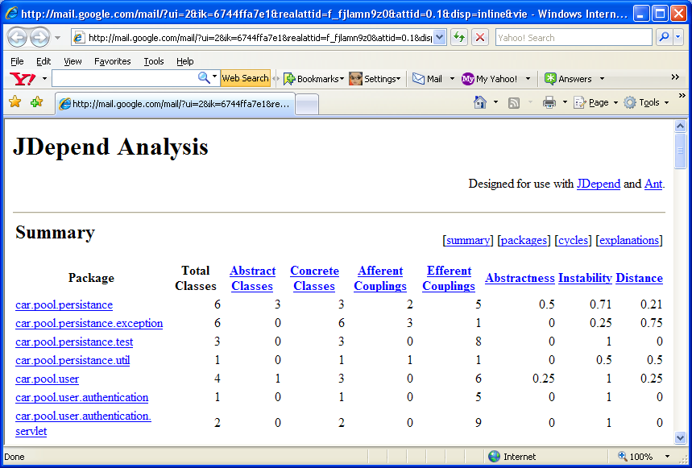

Figure 8: JDepend Analysis for Iteration One

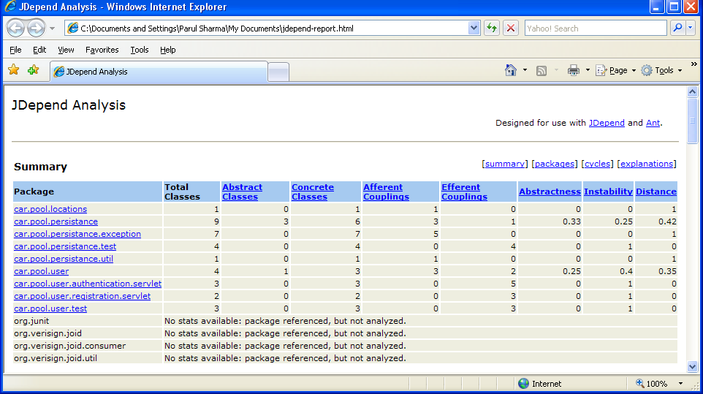

Figure 9: JDepend Analysis for Iteration Two

7. Conclusion

A combination of RUP and Agile methodology has been used for the development process of our iteratively prototypes project. The tools we have used for the purpose of this project include Google Code, Google Groups, Open Project, Subversion, MySQL, Visio, Tomcat and Eclipse. Java, Java Script, SQL and CSS are the main scripts and languages employed for the purposes of this project.

Currently on our system our users can register and log in using Open ID or usernames, they can add rides for dates (one-off rides) and accept these rides. On the ride page they are able to communicate with each other through comments. They are able to search for rides and then accept these rides. Users can see their details on their user account page. Google Calendar and Google Maps have been added for users for adding ride events and viewing the route a ride will take respectively. The issues with the server on which the site is to be hosted were resolved in this iteration.

We have continued to follow with the best practices of our methodology including developing iteratively as we aim to reexamine the output from iterations and improving upon them. Our requirements our managed through weekly meetings with our client and prototype demonstrations. The client gives us feedback on our system and we aim to incorporate these where possible and discuss points that we do not agree upon. Requirements are also managed by setting the boundaries of the system we are developing by maintaining our project scope. Component architecture is used in terms of developing small parts of our system independently and integrating each little part as it is completed into the whole working system. We aim to verify the quality of our products and processes through our SQA system which includes unit testing, integration testing, usability testing and process monitoring. Change is controlled by ensuring that the potential change to occur is discussed by all stakeholders and a mutual agreement is reached. Once an agreement is reached documentation in the repository is updated to reflect these changes so that all stakeholders are aware of the change.

http://www.linz.govt.nz/placenames/streets-and-places-database/index.aspx
http://www.useit.com/alertbox/20000319.html

